Grade 7 Accelerated · Unit 3 · Thread A · Day 2  Negative Exponents with Variable Bases  Question Bank 3.T2 ANSWER KEY | Name  Date  Period

Show your work. Circle your final answer.
For questions 1 through 6, write an equivalent expression using only positive exponents. Assume no variable equals 0.
1. 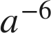


2. 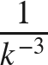


3. 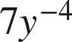

The 7 has no negative exponent; it stays in the numerator.

4. 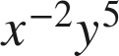
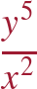

5. 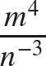


6. 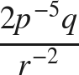
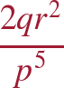
p⁻⁵ moves down; r⁻² moves up; 2 and q stay.

For questions 7 and 8, apply the laws of exponents. Write each answer using only positive exponents.
7. Write an equivalent expression.
a. 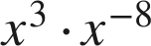
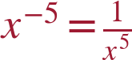
b. 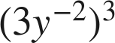
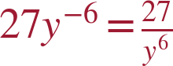
c. 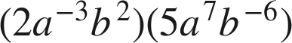
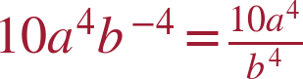

8. Write an equivalent expression.
a. 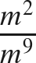
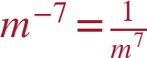
b. 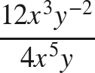
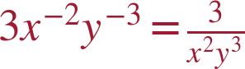
3 − 5 = −2; −2 − 1 = −3.
c. 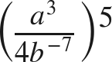
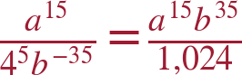

Working backwards.
9. Find the value of that makes each statement true.
a. 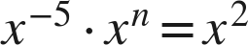
n = 7
b. 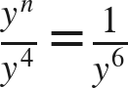
n = −2
n − 4 = −6.
c. 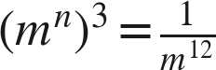
n = −4
3n = −12.

10. Let 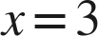.
a. Find the value of  and the value of 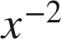.
9 and 1/9
b. Find the value of 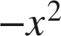. Is it equal to ? Explain.
−9. No — 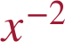 is the reciprocal of 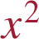, which is 1/9;  is the opposite of .

11. Which expression is equivalent to 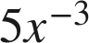 ?
○ A. 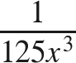
● B. 
○ C. 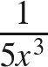
○ D. 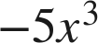
B

12. Select ALL of the expressions that are equivalent to 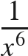.
☒ A. 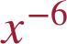
☒ B. 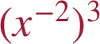
☒ C. 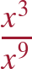
☐ D. 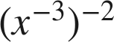
☐ E. 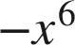
☒ F. 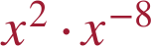
A, B, C and F

